CELEBAL INTERNSHIP
NAME – ANMOL BHATIA
Q1: What are the key limitations of traditional MapReduce that make Spark a preferred choice for modern big data processing?
Traditional MapReduce has a few limitations that make it less suitable for today's big data workloads. One of the biggest drawbacks is that it writes intermediate data to disk after every processing stage, which slows down execution because disk operations are much slower than memory. It is also not efficient for iterative tasks like machine learning, where the same data needs to be processed multiple times. In addition, writing MapReduce programs is more complex since developers need to define separate Map and Reduce functions.
Apache Spark addresses these issues by processing data in memory whenever possible, which greatly improves performance. It also provides simple DataFrame and SQL APIs, making data processing easier to write and understand. Because of its speed, ease of use, and support for analytics, machine learning, and streaming, Spark has become a preferred choice for modern big data processing.

Q2: Explain how Spark uses In-Memory Computing to speed up iterative machine learning algorithms compared to disk-based systems.
Spark speeds up iterative machine learning tasks by keeping data in memory instead of reading it from disk after every iteration. In systems like MapReduce, the same data is loaded from disk repeatedly, which increases execution time. Spark loads the data once and reuses it from memory, reducing disk I/O and improving performance. It also supports caching, allowing frequently used datasets to stay in memory for faster processing.

Q3: Write a code snippet to remove all duplicate rows from a DataFrame based on a specific set of columns: user_id and transaction_date.\
df_clean = df.dropDuplicates(["Customer ID", "Order Date"])
df_clean.show()

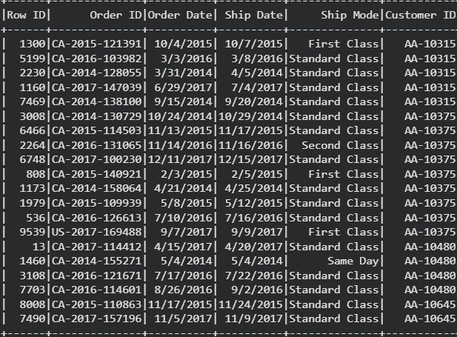

Q4: Given a DataFrame df_sales, write a query to filter for rows where the region is 'West' and then group by product_category to find the average sale_amount.
from pyspark.sql.functions import expr, avg
df_fixed = df.withColumn( "Sales",expr("try_cast(Sales as double)"))
q4_result = (df_fixed.filter(df_fixed["Region"] == "West").groupBy("Category")
.agg(avg("Sales").alias("Average Sales"))
)
q4_result.show()
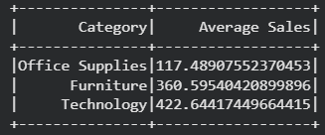

Q5: What is the difference between .na.drop() and .na.fill()? Provide a code example of filling null values in a status column with the string 'Unknown'.
.na.drop() removes rows that contain null values, while .na.fill() replaces null values with a specified value instead of deleting the rows. Using .na.fill() helps preserve the data by filling missing values where appropriate.

Q6: Write a query to find the total count of records for each city in a DataFrame, but only for cities where the count is greater than 100.
from pyspark.sql.functions import count, col
q6_result = ( df.groupBy("City").agg(count("*").alias("record_count"))
.filter(col("record_count") > 100)
)
q6_result.show()
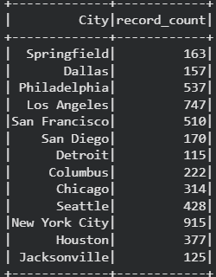

Q7: How does the immutability of Spark DataFrames affect how you perform "data cleaning" steps like dropping columns or renaming them?
Spark DataFrames are immutable, which means they cannot be changed after they are created. When performing data cleaning tasks such as dropping or renaming columns, Spark creates a new DataFrame instead of modifying the existing one. This helps maintain data consistency and allows transformations to be applied safely without affecting the original data.
Q8: Write a Spark command to filter a dataset for rows where the age is between 18 and 30 (inclusive) and the subscription is 'Premium'.
from pyspark.sql.functions import col
q8_result = sample_df.filter((col("age").between(18, 30)) &
(col("subscription") == "Premium")
)
q8_result.show()
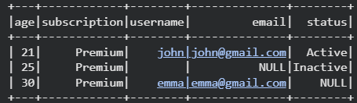

Q9: When cleaning a dataset, why is it often better to handle null values before performing mathematical aggregations like sum() or avg()?
Null values should usually be handled before using functions like sum() or avg() because they can affect the accuracy of the result. Spark may ignore null values during aggregation, which can make the final value misleading if many records are missing. Cleaning or filling nulls first makes the calculation more consistent and helps ensure that the result represents the dataset properly.

Q10: Write the code to revise a column named raw_timestamp by casting it to a TimestampType and renaming it to event_time.
from pyspark.sql.functions import col
from pyspark.sql.types import TimestampType
q10_result = sample_df.withColumn("event_time", col("raw_timestamp").cast(TimestampType())
).drop("raw_timestamp")
q10_result.select("event_time").show()
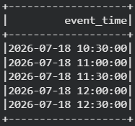

Q11: Explain the "Shuffle" process that occurs during a grouping operation. Why is it considered a wide transformation?
A shuffle is the process where Spark redistributes data across different partitions during operations like groupBy(), join(), or distinct(). This is needed because related data must be brought together before the operation can be completed. Shuffle is considered a wide transformation because it involves moving data between partitions, which increases network communication and makes the operation slower than narrow transformations.

Q12: Write a code snippet that identifies and removes rows where the email column contains null values OR the username is an empty string.
from pyspark.sql.functions import col
q12_result = sample_df.filter(col("email").isNotNull() &
(col("username") != ""))
q12_result.show()
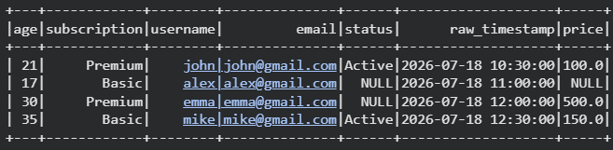

Q13: How do you use the .agg() function to calculate multiple statistics at once, such as the min, max, and mean of the price column?

from pyspark.sql.functions import min, max, avg
q13_result = df_fixed.agg(
min("Sales").alias("Minimum Sales"),
max("Sales").alias("Maximum Sales"),
avg("Sales").alias("Average Sales")
)
q13_result.show()
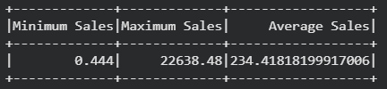
Q14: In the context of cleaning a dataset, what is the risk of using inferSchema=true when your source data contains messy or inconsistent date formats?
Using inferSchema=True can be risky when the dataset contains inconsistent date formats. Spark decides a column’s data type by examining the values, so mixed formats may cause the column to be detected as a string instead of a date or timestamp. Some values may also become null when they are later converted. It is safer to define the schema manually and clean or standardize the date values before casting them.
Q15: Write a final processing pipeline that:
- Filters out duplicates.
- Fills null prices with 0.
- Groups by store_id to calculate total revenue.

from pyspark.sql.functions import col, sum
q15_result = (df_fixed.dropDuplicates().na.fill({"Sales": 0})
.groupBy("Customer ID")
.agg(sum("Sales").alias("Total Revenue")))
q15_result.show()
